1. Find all customer related information who have an account in a branch, located in the same city as where they live. (write this query without using subqueries and then using a subquery) Using Subqueries:
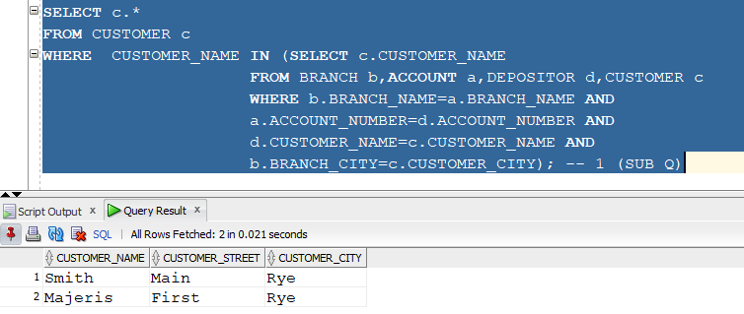
Without Using Subqueries:
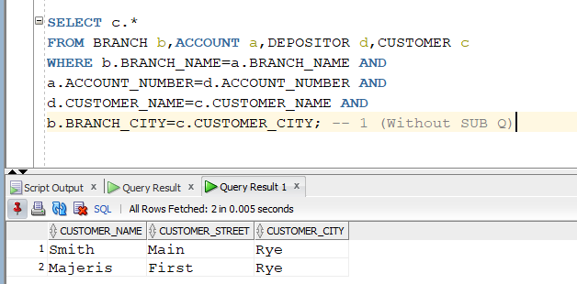
2. Find all customer related information who have a loan in a branch, located in the same city as where they live. (write this query without using subqueries and then using a subquery)
Using Subqueries:
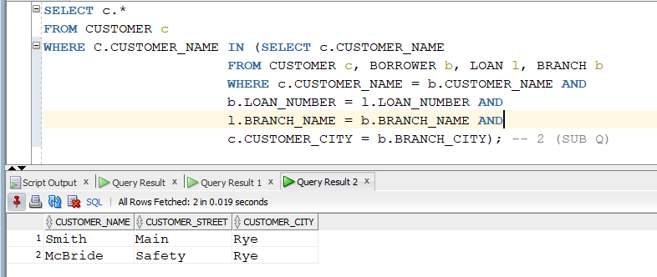
Without Using Subqueries:
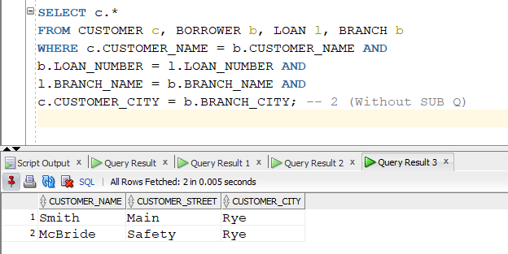
3. For each branch city, find the average balance of all the accounts opened in a branch located in that branch city. Do not include any branch city in the result where the total balance of all accounts opened in a branch located in that city is less than 1000. (Write this query with and without using ‘having’ clause)
WITH HAVING:
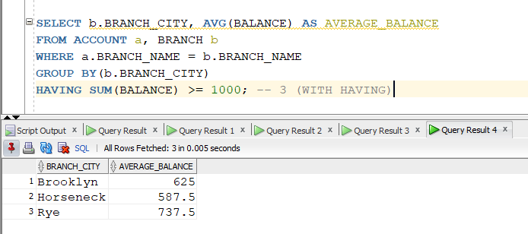
WITHOUT HAVING:
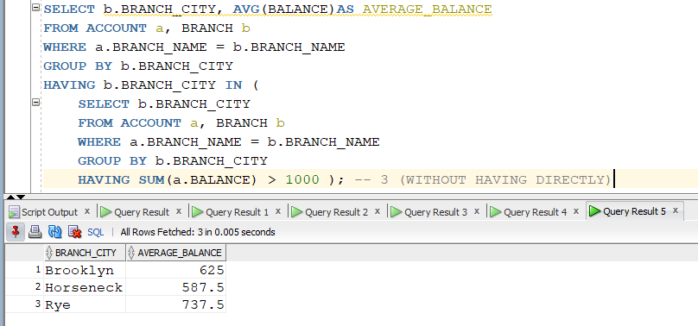
4. For each branch city, find the average amount of all the loans opened in a branch located in that branch city. Do not include any branch city in the result where the average amount of all loans opened in a branch located in that city is less than 1500. (write this query with and without using ‘having’ clause)
WITH HAVING:
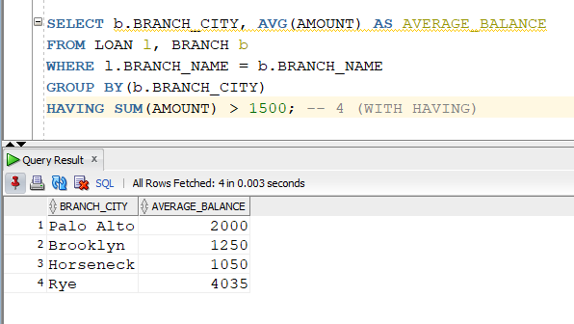
WITHOUT HAVING:
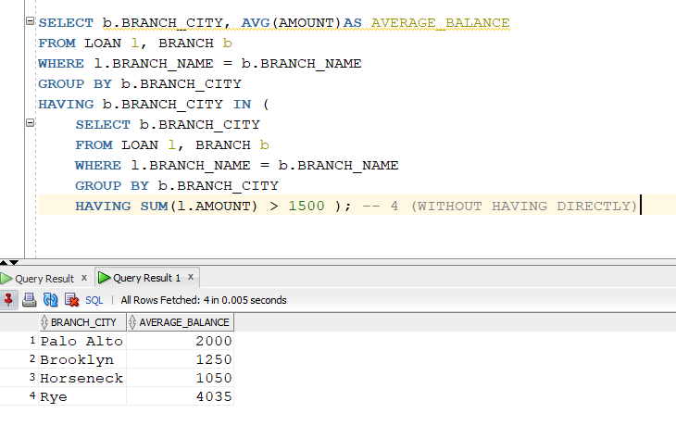
5. Find the customer name, customer street, customer city of the account which has the highest balance among all the accounts. (Write this query with and without using all keyword)
With ALL:
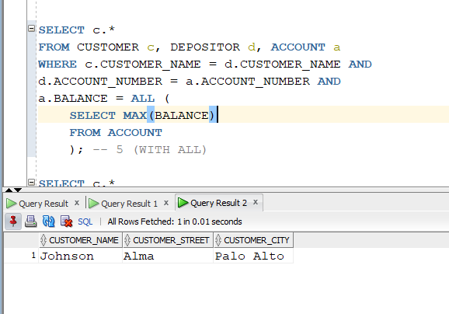
Without ALL:
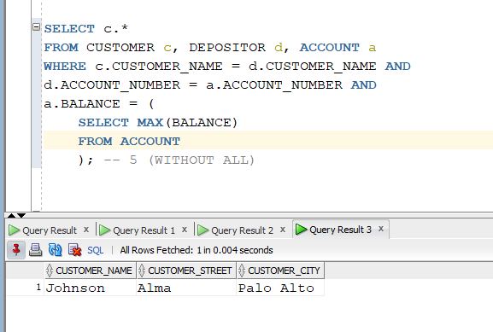
6. Find the customer name, customer street, customer city of the loan which has the lowest amount among all the loans. (write this query with and without using all keyword)
With ALL:
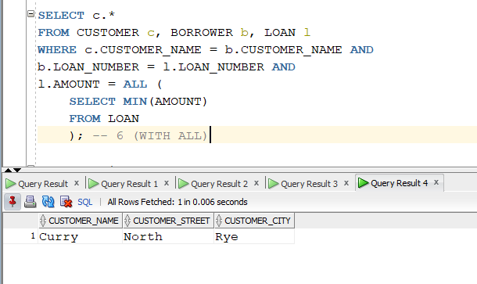

Without ALL:
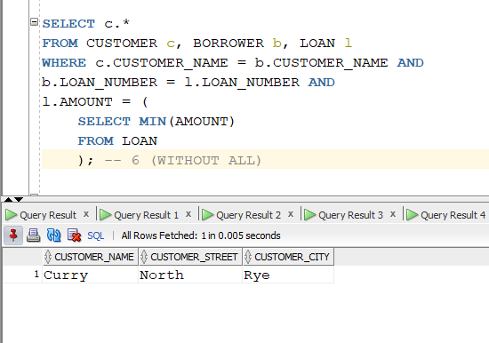
7. Find the distinct branches (name and city) that have opened both accounts and loans. (Write this query using in and exists keyword)
Using IN:
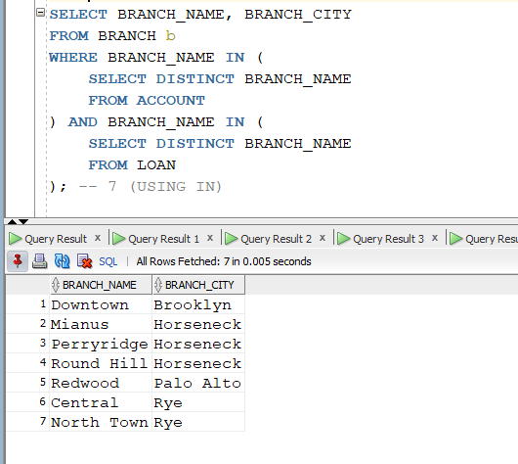
Using Exists:
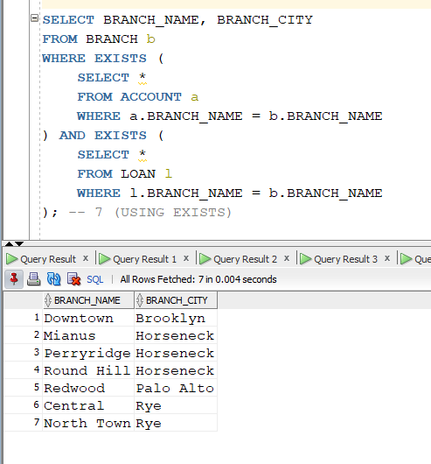
8. Find the distinct customers (name and city) who do not have loans but have accounts. (write this query using not in and not exists keyword)
Using NOT IN:
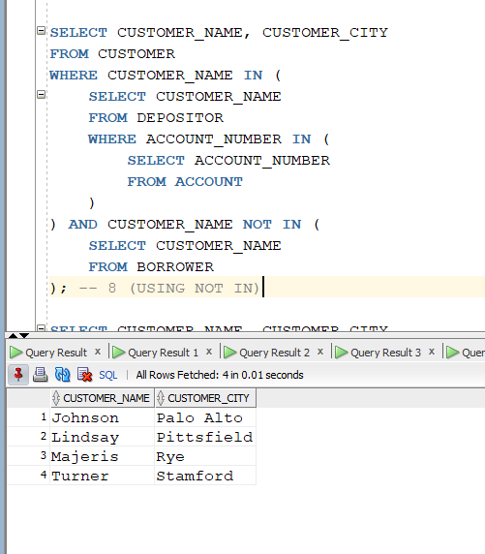
Using NOT EXISTS:
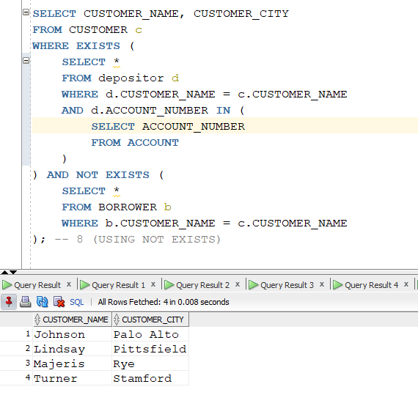
9. Find those branch names which have total account balance greater than the average of total balance among all the branches. (write this query with and without using with clause)
Using WITH CLAUSE:
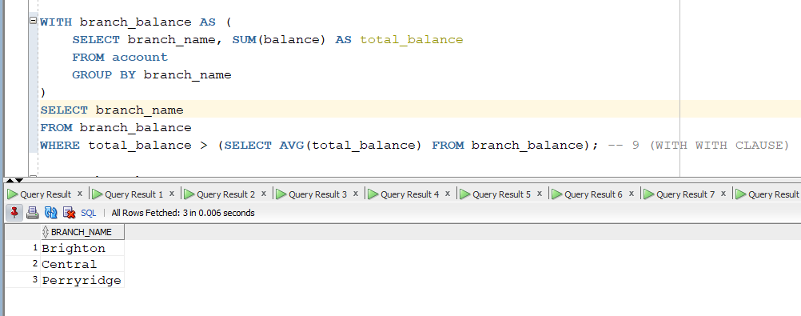
Without Using WITH CLAUSE:
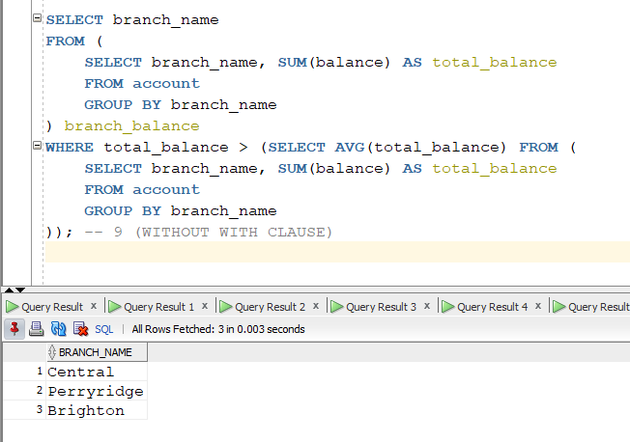
10. Find those branch names which have a total loan amount less than the average of the total loan amount among all the branches. (write this query with and without using with clause)
Using WITH CLAUSE:
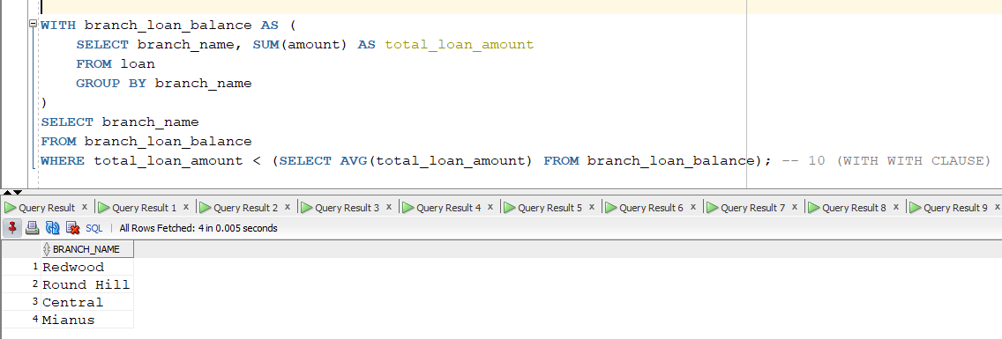
Without Using WITH CLAUSE:
